

1
Recruitment Pack
Empowering women, changing lives
Thank you for your interest in working for Nottingham Central Women’s Aid, a vibrant and dynamic organisation with the ethos of ‘Women supporting women’.
This pack contains the following information
- Who we are
- About Nottingham Central Women’s Aid
- Application form
- Attached are the Job description and Person specification which you will need to refer to in order complete the form

Many of our team including volunteers and our board of directors are survivors of domestic violence, we work to the ethos of 'Women supporting women' and encourage applications from those with lived experience similar to those of our beneficiaries.
Our aims are to promote the protection of women and children who have been subjected to domestic or sexual violence and abuse and to provide temporary safe accommodation on request. In Women's Aid's view, domestic violence is physical, psychological, sexual or financial violence that takes place within an intimate or family-type relationship and forms a pattern of coercive and controlling behaviour. This includes forced marriage, so-called 'honour' crimes and female genital mutilation.
About central Women’s Aid
Our Charity was originally founded in the 1970s to support women and children experiencing domestic violence and abuse. The service has accommodated thousands of women and children over the years supporting families to rebuild their lives free from fear.
We are an independently run registered charity- number 1146410 and a registered company. We now have some funding in place for our small team of part time workers but rely heavily on our fantastic team of volunteers to continue our work.
Dear Applicant

Thank you for your interest in a role at Central Women’s Aid.

We love diversity and we value your difference, your unique skills, knowledge and experience. Becoming part of our organisation may realise your potential, helping us to raise our performance in delivering excellent support to the diverse women and children we support.

We welcome all applications especially from women who identify as Black, Asian and Minority Ethnic or those who identify as from a marginalised or underrepresented background.

The following documents are enclosed in this application pack:
- Application form
- Monitoring form
- Equal Opportunities Statement

The job description and person specification are available on our website
www.centralwomensaid.org

Closing date for applications is detailed on the advert.
We reserve the right to end recruitment early.

Interviews: Dates and arrangements to be confirmed with the shortlisted applicants.

Please note that CVs will not be accepted unless they address all the points detailed within the person specification.

Applications will be assessed and shortlisted against the person specification so please make sure that you cover all the points in your application. Due to the volume of applications we receive, we are not able to provide feedback on non-shortlisted applications. However, feedback will be provided to candidates who attend interviews. An enhanced DBS check will be carried out prior to appointment.

It is an Occupational Requirement that applications are open to women only, as permitted under Schedule 9 (1), of the Equality Act 2010 and is exempt under Section 7 (2) (f) of the Sex Discrimination Act 1975 .

Please return all completed application forms FAO: CEO, NCWA, PO Box 20, Nottingham, NG3 5BA or email to Admin@centralwomensaid.org

Once again, thank you for your interest and good luck with your application.

Yours sincerely

For and on behalf of The Management Committee

Application form

Please complete this form and return it to: Admin@centralwomensaid.org

Nottingham Central Women’s Aid is the data controller for the information you complete on this form. We will ask you for information to be able to assess your suitability for the role you are applying for and to communicate with you throughout the application and recruitment process.

The data on this form will be processed and stored securely. The information will only be shared with employees involved in the recruitment process. We will not share your information with any other organisation.

For unsuccessful applicants’ information supplied will be kept for 1 year to enable any queries regarding the recruitment process to be dealt with; the form will then be disposed of. For successful applicants’ information will be transferred to a personnel file.

If you wish to remove your data from this process at any stage please contact: Admin@centralwomensaid.org

Role you are applying for:

Please state your preferred number of hours:
Your name and contact details
Title
Last name
First name(s)
Address
Postcode
Best phone number
Email address
NI number
Are you, or have you been known by any other name? | Yes ☐  No☐  Don’t know ☐
If yes, please give details
Please note that withholding information about being known by any other name could amount to gross misconduct.
To the best of your knowledge, are any relatives or family members employed by NCWA? | Yes ☐  No ☐  Don’t know ☐
If yes, what is your relation with them?

Are you a member of the DBS update service? | Yes ☐  No ☐  Don’t know ☐
If yes, do you give us permission to access this information?
Applicants should refer to the accompanying job description and person specification when completing this form.

Work experience (paid and unpaid)
Please begin with your most recent occupation (in chronological order) the box will expand.

Job title | Dates from/to | Employer | Key tasks | Current salary | Reason for leaving

Education/training/qualifications (gained or being studied for)
School/college/university | From/to | Qualifications | Date

Relevant non-accredited courses attended
Course | From/to | Date
Knowledge, Skills and Experience.
Please give examples to demonstrate how you meet each of the requirements detailed on the person specification criteria. Please give clear examples detailing your experience, knowledge and transferable skills that will make you suitable for the role.
Please use a separate example for each of the points on the person specification.
Any other information you feel relevant to the role.

We require two referees, one of whom should be your current or last employer. References may be taken up on shortlisted applicants PRIOR to interview unless you indicate otherwise below.
 | Referee 1 | Referee 2
Name of referee
Address of referee
Postcode
Telephone
Email
Occupation and Job role
Relationship to you
Agree to reference PRIOR to interview?
YES/NO
Do you have the legal right to work in the UK? | Yes / No  If yes, please provide details  ( ) UK Citizen  ( ) Settled Status (Indefinite Leave to Remain)  ( ) Pre-Settled Status (EU Settlement Scheme)  ( ) Work Visa (e.g., Skilled Worker, Health and Care Worker)  ( ) Student Visa with Work Permission  ( ) Other (please specify) ______________

Convictions
This post is exempt from the Rehabilitation of Offenders Act 1974 and a comprehensive screening process will be undertaken on successful applicants including a Disclosure & Barring Service check (DBS) including checks with past employers.

Have you ever been formally cautioned or convicted of any criminal offence? | Yes ☐  No ☐

The successful applicant will be given the opportunity to discuss this further if required.

Safeguarding

This organisation is committed to safeguarding and promoting the welfare of children, young people and adults with care and support needs and expects all staff and volunteers to share this commitment.

I certify that the information contained in this form is correct

Signed Date

Please indicate where you saw this vacancy

Equality and Diversity Policy Statement
We are an organisation run by women for women and children and are committed to promoting and valuing equality and diversity in all of our activities. We welcome and celebrate the richness and diversity of the communities in Nottinghamshire and are strongly committed to achieving equal opportunities and access for all in society.

We seek to create conditions whereby all staff and volunteers are treated solely on the basis of their merits, abilities and potential regardless of age, appearance, body size, caring responsibilities, caste, class, culture, disability, ethnic or national origin, family circumstance, gender reassignment, HIV status, homelessness, immigration status, learning ability, nationality, race, religious or political beliefs, sexual orientation or other irrelevant distinction. Equality and diversity is the cornerstone of all of our policies and procedures. We are proud of our diversity and the actions we take to eliminate discrimination and prejudice, to ensure inclusion and engagement for everyone who needs our support, works or volunteers with us. We will continue to strive towards a culture that is inclusive, and which recognises and develops the potential of all our staff, volunteers and beneficiaries.

Monitoring Form

NCWA is committed to promoting and valuing equality and diversity and we seek to recruit staff who contribute to the diversity of the organisation. To monitor the effectiveness of the NCWA Equality, Diversity and Inclusion, Policy and to ensure that no direct or indirect discrimination is taking place, all staff and candidates are asked to complete the NCWA Equalities Monitoring Form. NCWA assures you that any information you provide here will only be used to monitor the effectiveness of our policies and we will take steps to ensure this information remains confidential to a limited number of staff.

Monitoring questions
How would you describe your ethnicity?
Choose ONE section from A to D, and then tick the appropriate box
A WHITE

☐ British (English/Welsh/Scottish/Northern Irish)
☐ Irish
☐ Gypsy or Irish Traveller
☐ Any other White background, please describe

_______________________________________________
B AFRICAN/CARIBBEAN/BLACK BRITISH

☐ African ☐ Caribbean
☐ Any other mixed/multiple ethnic background, please describe

________________________________________________
C ASIAN/ASIAN BRITISH

☐ Indian ☐ Pakistani
☐ Bangladeshi ☐ Chinese
☐ Any other Asian background, please describe

________________________________________________
D MIXED HERITAGE

☐ White & Black Caribbean ☐ White & Black African
☐ White & Asian
☐ Any other mixed heritage background, please describe

________________________________________________

What is your first language?

__________________________________

Do you speak any other languages, If so which?

__________________________________
Disability & Limiting Long-Term Illness (LLTI)

The 2010 Equality Act defines disability as ‘a physical or mental impairment which has a substantial and long term adverse [negative] effect on a person’s ability to carry out normal day to day activities.

‘Long Term’ is defined as lasting at least 12 months, where conditions can sometimes fluctuate (sometimes absent or less severe)

Do you consider yourself to have a disability or limiting long-term illness (LLTI)?

☐ Yes ☐ No ☐ Prefer not to say

If yes, please tick any of the following that apply:

☐ Physical ☐ Learning
☐ Mental Health ☐ Deaf/Hearing impaired
☐ Blind/Visually impaired ☐ Prefer not to say
☐ Other, please state __________________________________

Please indicate your age bracket

☐ 18 - 19 ☐ 50 - 59
☐ 20 - 29 ☐ 60+
☐ 30 - 39 ☐ Prefer not to say
☐ 40 - 49

What is your sexual orientation?

☐ Bisexual ☐ Gay Woman/Lesbian
☐ Heterosexual/Straight ☐ Prefer not to say
☐ Other, please state ____________________________

How your information is held

Most information is transmitted by email and is stored on our computers and paper-based filing. We use Microsoft which covers our emails server and Quickbooks for payroll. All this information can only be accessed by authorised staff within our organisation. Our staff are trained to understand the importance of keeping personal data secure.

Our computers are safeguarded by anti-virus software and the regular changing of security passwords. The information on candidates for specific roles will be held for 6 months in line with CIPD recommended best practice. After which paper files will be securely shredded and computer records deleted. Only if we have asked, and you have given your consent for the data to be held will this not apply.

Disclosure

We may disclose the information for the purpose of obtaining referees. Where additional information is required the information may be disclosed to the Disclosure and Barring Service, your GP or an Occupational Health professional only after you have given your consent.

You have specific rights in connection with personal information: request access to your personal information; request correction of the personal information that we hold about you; request erasure of your personal information; object to processing of your personal information where we are relying on a legitimate interest; request the restriction of processing of your personal information; request the transfer of your personal information to another party and the right to withdraw consent.

Complaints

Privacy complaints are taken very seriously and if you believe that we have breached your privacy you should in the first instance write to the trustees who have responsibility for the Data Protection within NCWA stating the details of your complaint.

We would ask that you provide us with as much detail as possible to allow a thorough investigation. Your complaint will be acknowledged within 24 hours and we aim to resolve any complaint within 5 working days. However, depending on the complexity of the complaint and availability of external agencies it may on occasions take longer.

Should your complaint show that we have breached our duty of care we will report the breach to the Information Commissioners Office. If you are not satisfied by our response you may complain to the ICO.

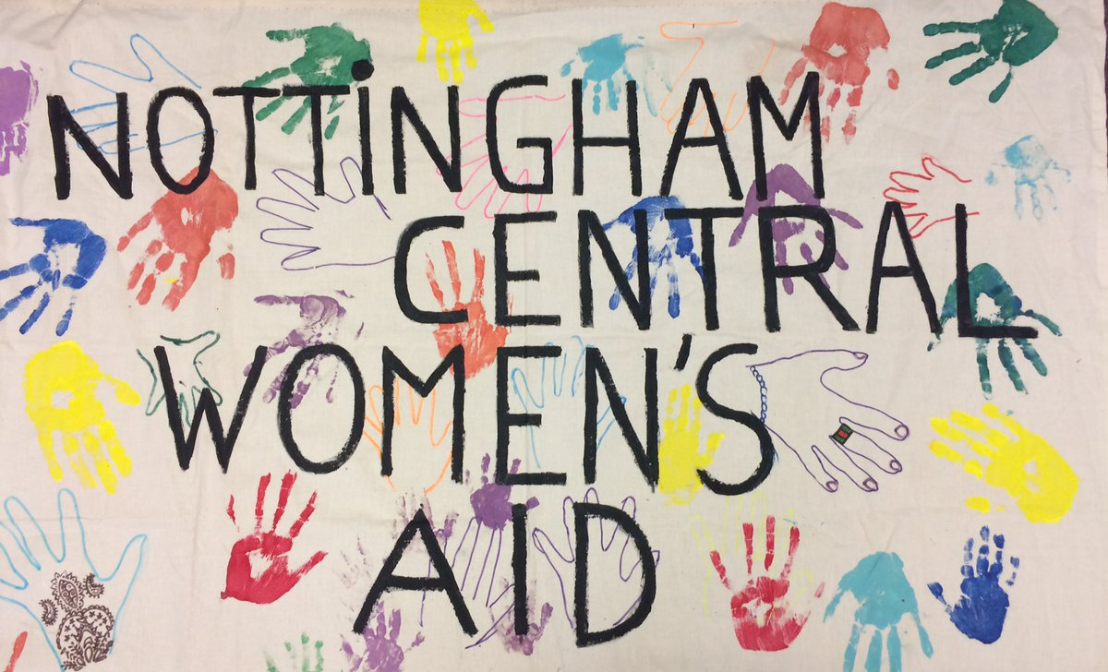

www.centralwomensaid.org

Please complete this form and return it to: Admin@centralwomensaid.org
(Strictly no agencies)

